The SDN/NFV architecture of Verizon
The main goal of the Verizon SDN / NFV architecture is to increase operational efficiency and agility of services, save CAPEX and APEX on the SDN / NFV COTS infrastructure, and transform the operator's business, using the synergy of both SDN and NFV technologies.
In the SDN part, Verizon also attaches great importance to separation of data plane and control plane. Verizon’s term of data plane is “media-plane”, thereby emphasizing the importance of video services as the basis of the operator's business, which replaces traditional voice and SMS services.
A special feature of the architecture is the "E2E Orchestration", which is higher in hierarchy than the traditional NFV MANO and SDN controller. This level is responsible for coordinating the work of traditional (inherited) network elements and virtualized network elements, that is, Verizon attaches great importance to supporting the available technology for a fairly long period of its gradual replacement with virtualization technology.
White Box Open Source Solution
On May 2, 2017, Shawn Hakl, Vice President Of New Products and Innovations at Verizon, announced at the 2017 NFV World Congress in San Jose, California, that Verizon would soon launch an open source solution “white box”, on which software solutions from many vendors can work simultaneously. According to him, this solution is expected by many corporate customers of Verizon. He did not disclose what specific vendor technologies this solution would be based on, but noted that it would be a "mix of traditional and non-traditional suppliers".
Verizon's financial results
At the moment of Report writing, the digital transformation has not affected the results of financial activity Verizon yet.
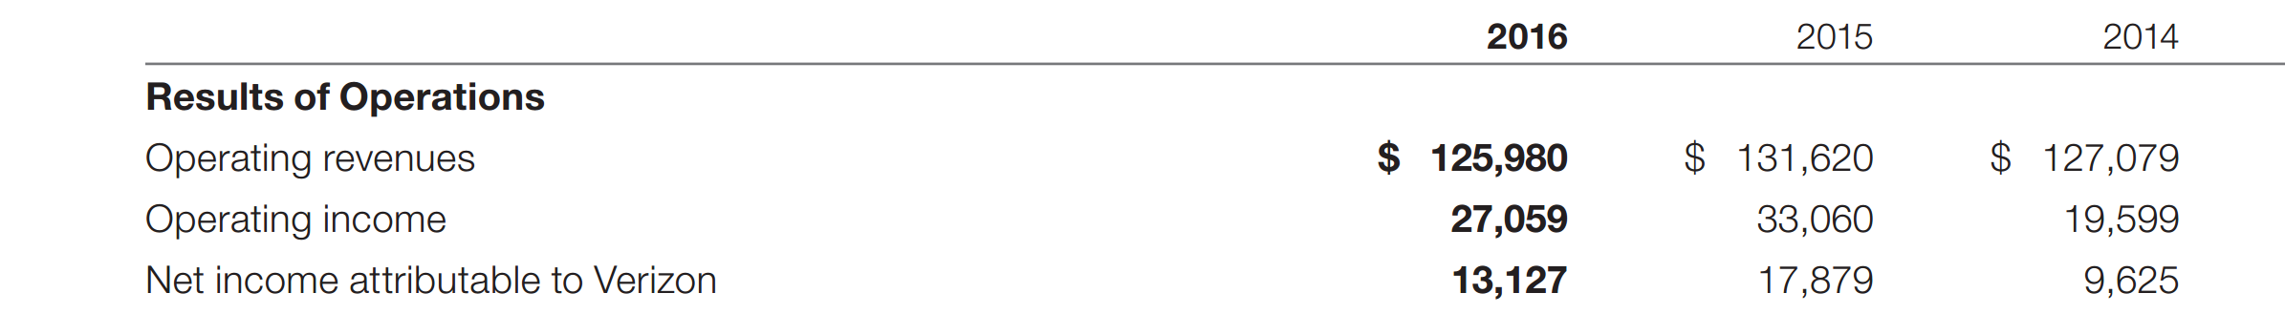
Source: Verizon.
Fig. 4.23. The financial results of Verizon pf 2014 - 2016 (million US dollars).
The figure below shows a comparison of AT & T's revenue growth from fixed-line services, compared to Verizon's revenue:

Source: STL Partners
Fig. 4.24. Comparison of revenue growth of AT&T and Verizon in 2012Q1 – 2016Q2.

